LLC “Ecolin and K”

Supply Base Report Template for Biomass Producers

www.sustainablebiomasspartnership.org

Version 1.2

June 2016

NOTE:
This template, v1.2, is effective as of the date of publication, that is, 23 June 2016. Template v1.1 may still be used for those audits undertaken prior to 23 June 2016 and where the certificate is issued to Certificate Holders before 1 October 2016.

For further information on the SBP Framework and to view the full set of documentation see https://sbp-cert.org/

Document history
Version 1.0: published 26 March 2015
Version 1.1 published 22 February 2016
Version 1.2 published 23 June 2016

© Copyright The Sustainable Biomass Partnership Limited 2016

Contents
1 Overview 1
2 Description of the Supply Base 2
2.1 General description 2
2.2 Actions taken to promote certification amongst feedstock supplier 5
2.3 Final harvest sampling programme 5
2.4 Flow diagram of feedstock inputs showing feedstock type [optional] 5
2.5 Quantification of the Supply Base 5
3 Requirement for a Supply Base Evaluation 7
4 Supply Base Evaluation 8
4.1 Scope 8
4.2 Justification 8
4.3 Results of Risk Assessment 8
4.4 Results of Supplier Verification Programme 8
4.5 Conclusion 8
5 Supply Base Evaluation Process 9
6 Stakeholder Consultation 10
6.1 Response to stakeholder comments 10
7 Overview of Initial Assessment of Risk 11
8 Supplier Verification Programme 12
8.1 Description of the Supplier Verification Programme 12
8.2 Site visits 12
8.3 Conclusions from the Supplier Verification Programme 12
9 Mitigation Measures 13
9.1 Mitigation measures 13
9.2 Monitoring and outcomes 13
10 Detailed Findings for Indicators 14
11 Review of Report 15
11.1 Peer review 15
11.2 Public or additional reviews 15
12 Approval of Report 16
13 Updates 17
13.1 Significant changes in the Supply Base 17
13.2 Effectiveness of previous mitigation measures 17
13.3 New risk ratings and mitigation measures 17
13.4 Actual figures for feedstock over the previous 12 months 17
13.5 Projected figures for feedstock over the next 12 months 17

Overview
On the first page include the following information:
(Report period: 01/01/2016 – 31/12/2016)
Producer name: LLC “Ecolin and K”
Producer location: 223134, v. Ubolotye, AVM “Ubolotye” building, k. 1, Logoisk district, Minsk region, the Republic of Belarus
Geographic position: 54°24′54″N, 27°46′58″E or 54.414911 N, 27.782847 E
Primary contact: Titov Andrei, deputy director, mob. Phone +375291147550, fax +375177422705,
e-mail: 1147550@list.ru
Company website: www.ecolin.by
Date report finalised: 15/02/2017
Close of last CB audit: 27/02/2017
Name of CB: UAB NEPCon LT
Translations from English: YES
SBP Standard(s) used: Standard 2 version 1.0; Standard 4 version 1.0; Standard 5 version 1.0;
Weblink to Standard(s) used: https://sbp-cert.org/documents/standards-documents
SBP Endorsed Regional Risk Assessment: N/A
Weblink to SBE on Company website: www.ecolin.by
Indicate how the current evaluation fits within the cycle of Supply Base Evaluations
Main (Initial)  Evaluation | First  Surveillance | Second Surveillance | Third  Surveillance | Fourth  Surveillance
☐ | X | ☐ | ☐ | ☐

Description of the Supply Base

General description
LLC “Ecolin and K” source the raw materials for pellets producing as feedstock primary and secondary. Secondary feedstock originating as forest residues from own production as well as from external sawmill. Primary feedstock source directly from FMU in Belarus. Feedstock are:
SBP-compliant Primary Feedstock – 31 % (FSC 100%)
Quantity of Suppliers – 4
SBP-compliant Secondary Feedstock -63,5% (FSC 100%)
Quantity of Suppliers – 2
SBP-non compliant Secondary feedstock – 5,5% (not certified)
Quantity of Suppliers – 1
Species: Species: Picea abies (L.) H. Karst.); Pinus sylvestris (L.);
Feedstock for FSC 100% and SBP- compliant pellets are primary and secondary feedstock from only FSC 100% wood.
Forest fund
Forest fund in Belarus includes forest covered area, as well as other area that is intended for the needs of forestry, and occupies 9.5 million hectares – 8.7 million hectares of this area is covered by forest. Woodiness of the Republic of Belarus is 39.5 %
As a result of purposeful work in reforestation, area covered by forest is increasing. Expansion happens both naturally and is facilitated by afforestation of infertile land that is not suitable for agriculture. In Belarus, at the same time with the increase of total area of forest fund, also regular increase of new, mature and overgrown plantations can be observed.
Total stock of wood is 1714 million cubic meters, including mature and overgrown plantations – 263 million cubic meters.
The average age of plantations – 54 years.
Distribution of forests by dominant species:
- pine – 50.3 %;
- spruce–9.2 %;
- birch – 23.2 %;
- black alder – 3.3 %;
- grey alder – 3.3 %;
- aspen – 2.1%;
- other species – 3.3 %.
Source: http://www.mlh.by

Forest management
Forest in the Republic of Belarus is exclusively state’s property. The Republic of Belarus carries out maintenance, usage and management of the forests via authorized institutions of forest management; the main functions of these institutions are management and usage of the forests. In accordance with the Forest Code, institutions of forest management are obliged to carry out measures of forest management according to legislation on forest and nature protection and to ensure compliance with the requirements of legislation on usage, protection, defense and replanting of the forests and protection of the environment.

Forest usage
Forest usage in Belarus is realized according to the principle of continuity and sustainability. Annual volume of the produced woods during 2016 was approximately 15,1 million cubic meters.
Source: http://www.mlh.by,

Biological diversity
Belarus is a signatory of the CITES Convention since 1995. Requirements of CITES are respected in forestry, although, in Belarus, there are no species included in the lists of CITES.
Annual reforestation is carried out over an area of 32 000 hectares, including 81 % of forest planting and 19 % of natural regeneration. http://belstat.gov.by/ (2015)
In the territory of Belarus, two state reserves – Berezinsky Biosphere Reserve (85.2 thousands hectares) and Polesie State Radioecological Reserve (216.1 thousands hectares) and four national parks –Bialowieza Forest (152.962 thousands hectares), Braslav Lakes (69.115 thousands hectares),national parks “Narochansky” (93.3 thousands hectares) and “Pripyatsky” (85 841 thousands hectares).
Forest and community
In 2016, all kinds of cuttings provided 15.1 million cubic meters of marketable timber while planned volume was 12,5 million cubic meters (that means plan was fulfilled for 120%). Cuttings volume of 2016 has grown up for 11,8 % for the level of 2015.
In 2016 in forest cutting sphere percentage of forest machines work increased for 46% (6,9 million cubic meters).
Positive balance of external trade was 140 million USA dollars. 2.6 million cubic meters of round timber and 324 000 cubic meters of sawn timber were sold abroad.
In 2016, forest products and services were exported to 25 states, including 2.0 % – to near countries and 98 % –to remote countries. Among the main forest export directions, leaders are: Poland (38.2 % of the total export volume in terms of value), Lithuania (16,6 %), Germany (10.2 %), Latvia (10.62%), the Netherlands (2.8 %), Romania (8,1%).
Source: http://www.mlh.by
Certification
Forest certification in the Republic of Belarus is carried out according to the requirements of international scheme of Forest Stewardship Council (FSC) and within the framework of forest certification system of National confirmation of conformity system which is approved by the Programme for the Endorsement of Forest Certification (PEFC).
According to the standards of FSC, 7,7 million hectares (90 forestry unit) are certified, that means 92,1% of all the fund. Conversely, according to the scheme of PEFC, 7.9 million hectares of forest fund (93 forestry units) are certified.
Both FSC and PEFC systems have found their way in Belarus.

Actions taken to promote certification amongst feedstock supplier
For the production of SBP-compliant pellets are used only FSC 100% certified supplier material. The company policy is to give a preference to certified suppliers. Raw material (sawdust) consists mostly of wood waste from own production and main production of suppliers. Therefore, uncertified and new suppliers are invited to certify their base production and get benefit from residues.

Final harvest sampling programme
N/A

Flow diagram of feedstock inputs showing feedstock type [optional]
N/A

Quantification of the Supply Base

Supply Base
- Total Supply Base area 8,7 milj (ha): Cumulative area of all forest types within SB
- Tenure by type (ha): Government 8,7milj./ ha
- Forest by type (ha): Temperate 8,7 milj,. ha
- Forest by management type (ha):Managed Semi-Natural 8,7, milj., ha
- Certified forest by scheme (ha):7,7 milj. ha FSC and 7,9 milj/ ha PEFC-certified forest

Feedstock
- Total volume of Feedstock: 6791,67 m3
- Volume of primary feedstock: 2132,97 m3
- List percentage of primary feedstock (g), by the following categories. Subdivide by SBP-approved Forest Management Schemes
  - Primary feedstock FSC 100% takes 100% of total volume and consists of FSC 100% wood (SBP-approved Forest Management Schemes)
  - Primary feedstock not certified to FSC and an SBP-approved Forest Management Schemes: non certified 0%
- List all species in primary feedstock, including scientific name
Picea abies (L.) H. Karst.); Pinus sylvestris (L.);
- Volume of primary feedstock from primary forest 0 m3
- List percentage of primary feedstock from primary forest (i), by the following categories. Subdivide by SBP-approved Forest Management Schemes
- Volume of secondary feedstock: 4658,70 m3 (Sawmill residue) feedstock as production waste from own production and other producers from Belarus.
- List percentage of secondary feedstock (l), by the following categories. Subdivide by SBP-approved Forest Management Schemes
  - Secondary feedstock FSC 100% takes 92% of total volume and consists of FSC 100% wastes (SBP-approved Forest Management Schemes)
  - Secondary feedstock not certified to FSC and an SBP-approved Forest Management Schemes: non certified 8%
- Species: Picea abies (L.) H. Karst.); Pinus sylvestris (L.);
- Volume of tertiary feedstock: 0 Specify origin and composition

Requirement for a Supply Base Evaluation
SBE completed | SBE not completed
☐ | X

Provide a concise summary of why a SBE was determined to be required or not required.

Supply Base Evaluation

Scope
Not applicable.

Justification
Not applicable.

Results of Risk Assessment
Not applicable.

Results of Supplier Verification Programme
Not applicable.

Conclusion
Not applicable.

Supply Base Evaluation Process
Not applicable.

Stakeholder Consultation
Not applicable.

Response to stakeholder comments
Not applicable.

Overview of Initial Assessment of Risk
Not applicable.

Supplier Verification Programme

Description of the Supplier Verification Programme
Not applicable.

Site visits
Not applicable.

Conclusions from the Supplier Verification Programme
Not applicable.

Mitigation Measures

Mitigation measures
Not applicable.

Monitoring and outcomes
Not applicable.

Detailed Findings for Indicators
Not applicable.

Review of Report

Peer review
The report was not reviewed on the reason of no any significant changes in comparison with the previous SBR report. No comments on the report.

Public or additional reviews
Public or additional reviews The English version of the report is available on the company's website www.ecolin.by for public inspection of all interested parties. After reading all the interested parties can send their comments, if any, at the company e-Mail: 1147550@list.ru

Approval of Report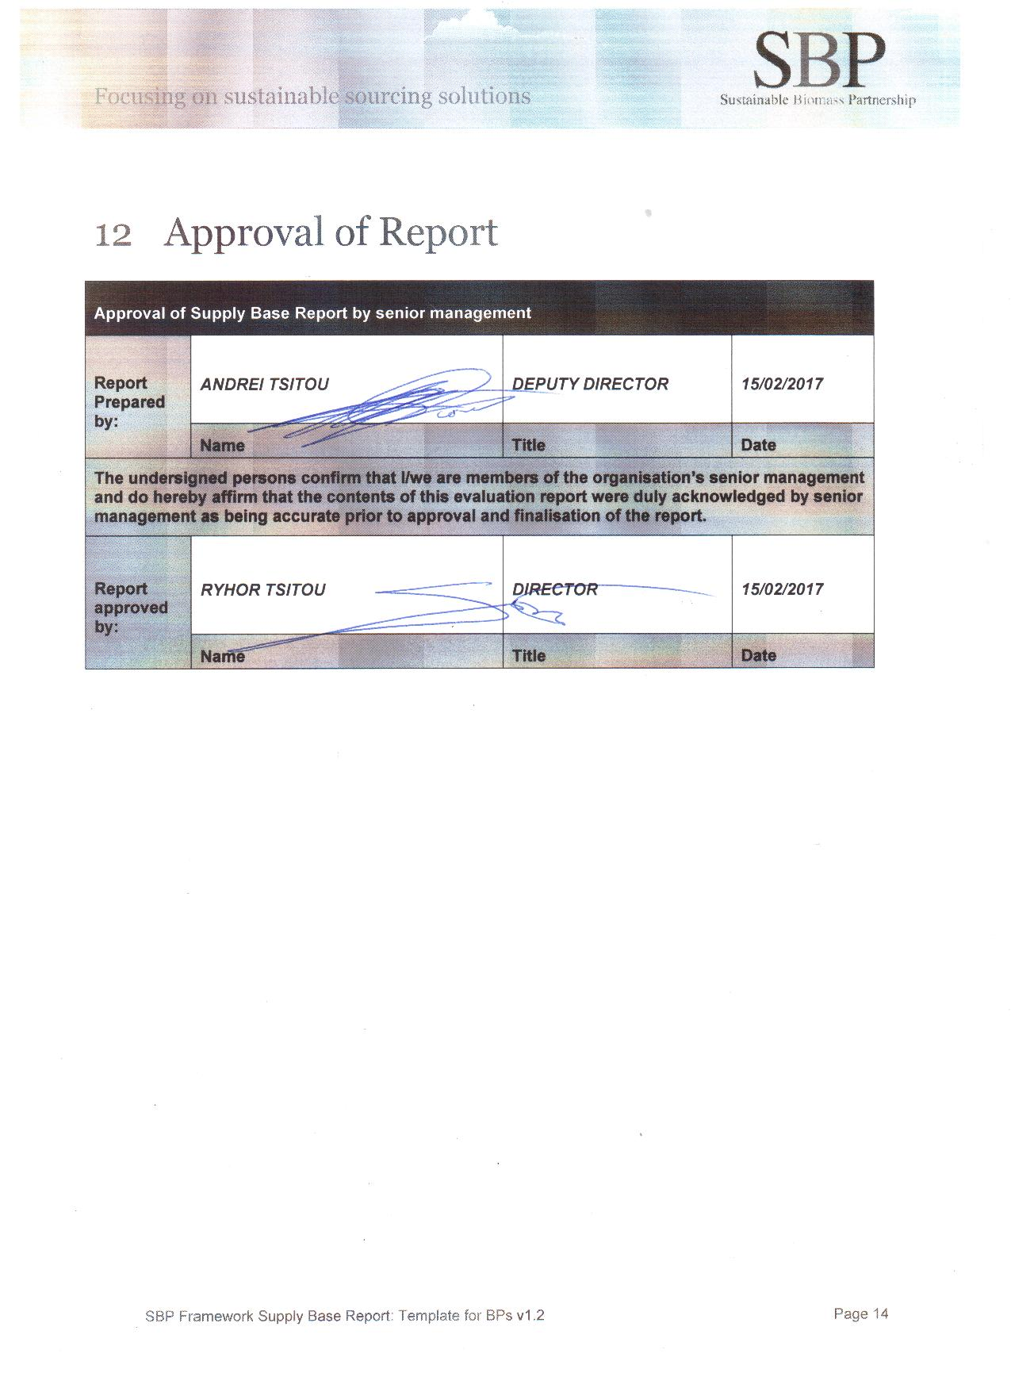

Updates
Not applicable.

Significant changes in the Supply Base
Not applicable.

Effectiveness of previous mitigation measures
Not applicable.

New risk ratings and mitigation measures
Not applicable.

Actual figures for feedstock over the previous 12 months
6791,67 m3

Projected figures for feedstock over the next 12 months
7000 m3

